Digital Currency
# Source: AI Source: Provided by: [Data Path: Persons Table -> ID Column: 1, Name_En Column: Motasem Essam] -> From: [ChatGPT] on [7/17/2026]

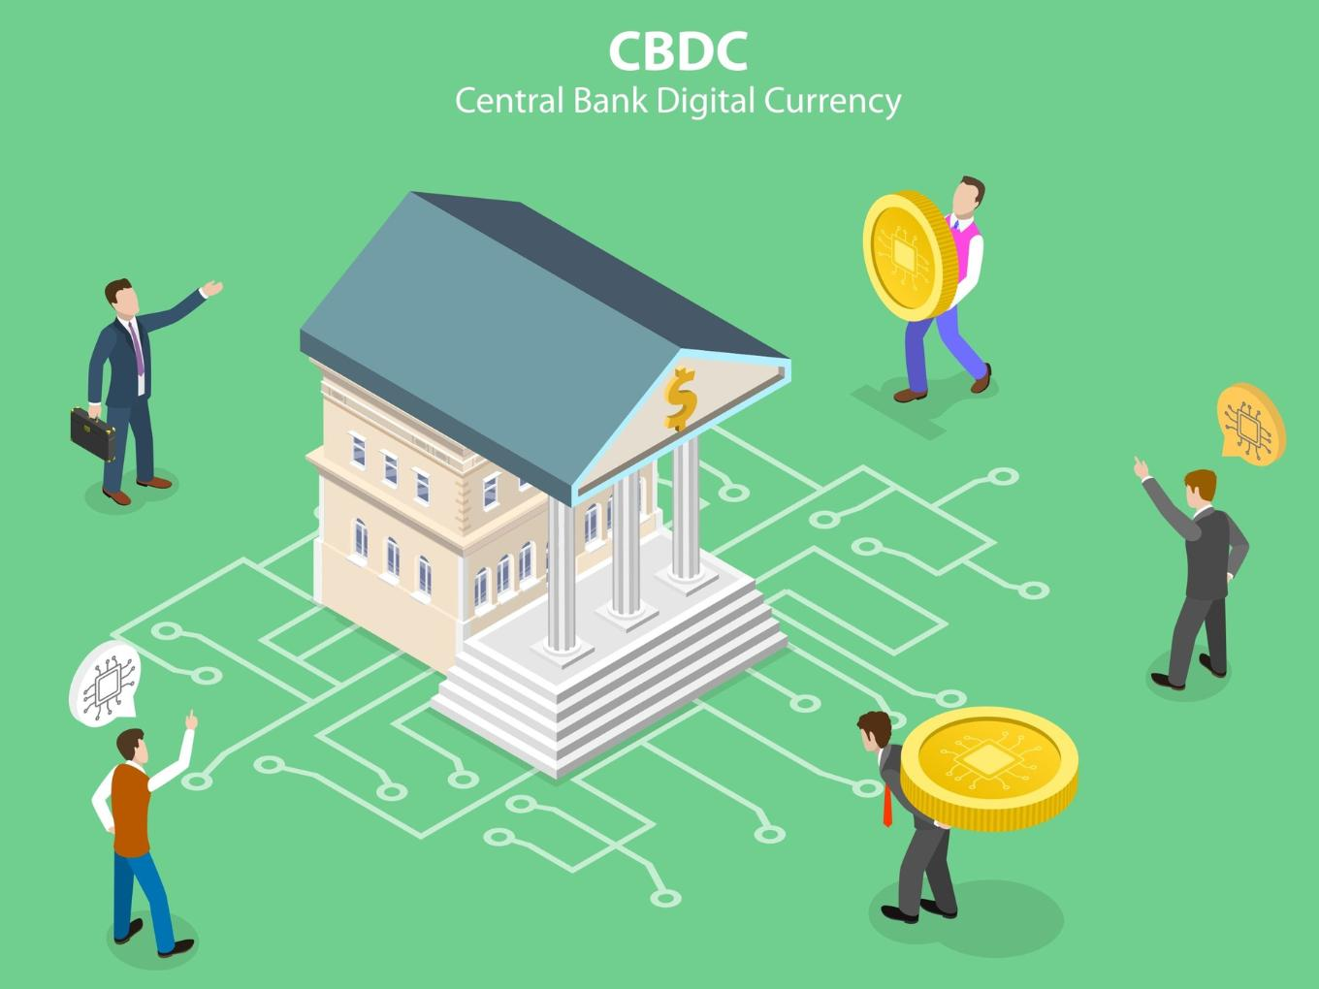
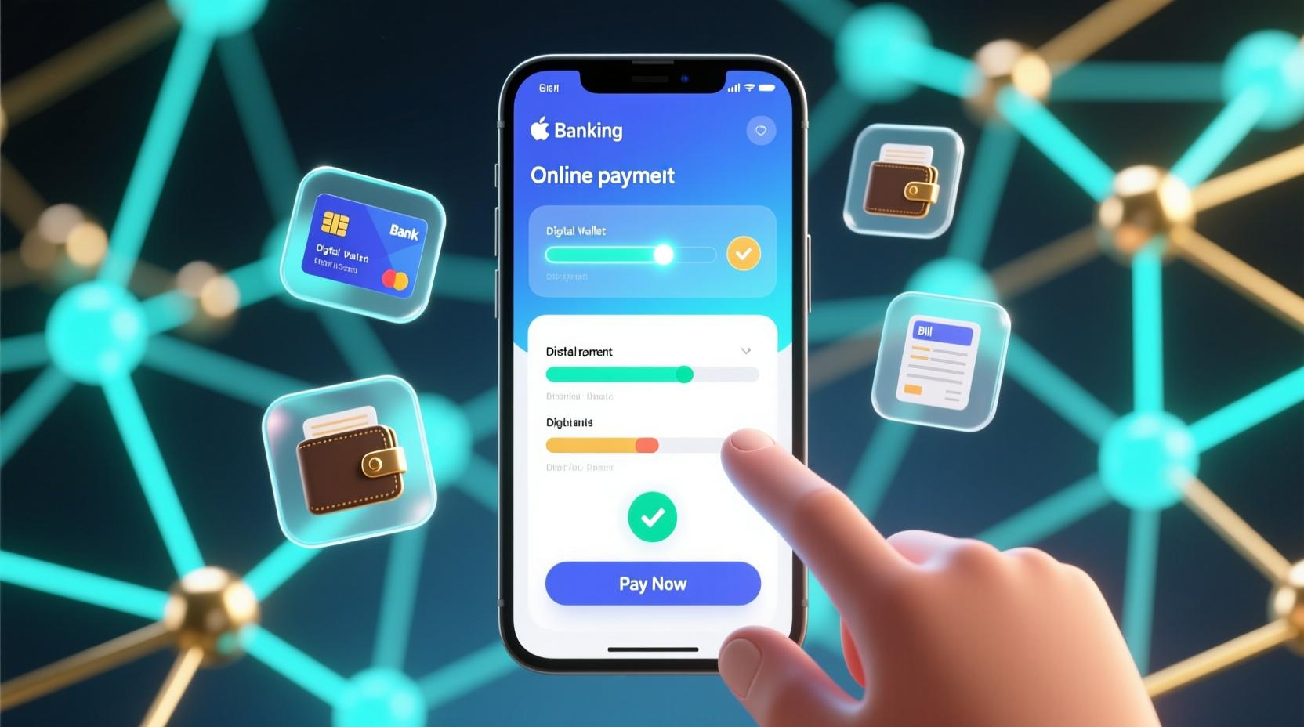
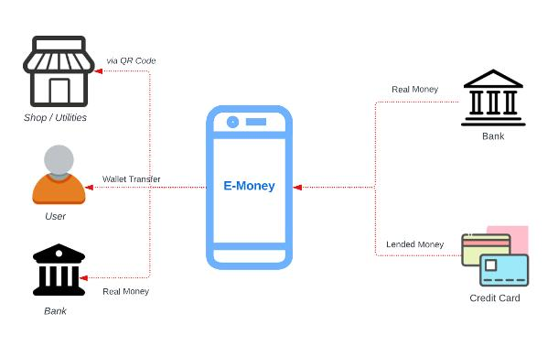

Digital Currency is a form of currency that exists only in electronic form. Unlike physical banknotes and coins, digital currencies are stored, transferred, and used through computers, smartphones, banking systems, or digital networks.
Digital currencies can be issued by central banks, commercial banks, or private organizations, depending on the type of digital currency.

Definition
# Source: AI Source: Provided by: [Data Path: Persons Table -> ID Column: 1, Name_En Column: Motasem Essam] -> From: [ChatGPT] on [7/17/2026]
Digital Currency is a form of currency that exists electronically and is used to store, transfer, and exchange monetary value without requiring physical cash.

Characteristics of Digital Currency
# Source: AI Source: Provided by: [Data Path: Persons Table -> ID Column: 1, Name_En Column: Motasem Essam] -> From: [ChatGPT] on [7/17/2026]
Digital currency is:
- Electronic only.
- Stored digitally.
- Transferred electronically.
- Accessible through computers and mobile devices.
- Used for online and cashless payments.

How Digital Currency Works
# Source: AI Source: Provided by: [Data Path: Persons Table -> ID Column: 1, Name_En Column: Motasem Essam] -> From: [ChatGPT] on [7/17/2026]
A typical digital currency transaction follows these steps:
- The sender initiates a payment.
- The payment system verifies the transaction.
- Funds are transferred electronically.
- The recipient receives the digital currency.

Types of Digital Currency

1. Central Bank Digital Currency (CBDC)
# Source: AI Source: Provided by: [Data Path: Persons Table -> ID Column: 1, Name_En Column: Motasem Essam] -> From: [ChatGPT] on [7/17/2026]
A Central Bank Digital Currency (CBDC) is an official digital version of a country's national currency issued and regulated by its central bank.
Examples (under development or pilot projects):
- Digital Yuan (China)
- Digital Euro (proposed)
- Digital Pound (proposed)

2. Commercial Bank Money
# Source: AI Source: Provided by: [Data Path: Persons Table -> ID Column: 1, Name_En Column: Motasem Essam] -> From: [ChatGPT] on [7/17/2026]
Electronic money stored in:
- Checking accounts
- Savings accounts
Examples:
- Online banking balances
- Mobile banking accounts

3. Electronic Money (E-Money)
# Source: AI Source: Provided by: [Data Path: Persons Table -> ID Column: 1, Name_En Column: Motasem Essam] -> From: [ChatGPT] on [7/17/2026]
Money stored electronically by licensed payment providers.
Examples:
- Prepaid cards
- Electronic wallets
- Stored-value accounts

Storage
# Source: AI Source: Provided by: [Data Path: Persons Table -> ID Column: 1, Name_En Column: Motasem Essam] -> From: [ChatGPT] on [7/17/2026]
Digital currencies are commonly stored in:
- Bank accounts
- Mobile wallets
- Payment applications
- Digital wallets
- Electronic payment platforms

Applications
# Source: AI Source: Provided by: [Data Path: Persons Table -> ID Column: 1, Name_En Column: Motasem Essam] -> From: [ChatGPT] on [7/17/2026]
Digital currencies are used for:
- Online shopping
- Mobile payments
- Utility bill payments
- Salary deposits
- International transfers
- Government services
- Retail purchases

Advantages
# Source: AI Source: Provided by: [Data Path: Persons Table -> ID Column: 1, Name_En Column: Motasem Essam] -> From: [ChatGPT] on [7/17/2026]
Digital currencies provide:
- Fast transactions.
- Convenient payments.
- Reduced need for physical cash.
- Easier financial record keeping.
- Remote accessibility.
- Support for online commerce.

Limitations
# Source: AI Source: Provided by: [Data Path: Persons Table -> ID Column: 1, Name_En Column: Motasem Essam] -> From: [ChatGPT] on [7/17/2026]
Digital currencies:
- Depend on electronic systems.
- May require internet connectivity for many services.
- Require cybersecurity protection.
- May be affected by technical failures or power outages.

Digital Currency vs. Physical Currency
# Source: AI Source: Provided by: [Data Path: Persons Table -> ID Column: 1, Name_En Column: Motasem Essam] -> From: [ChatGPT] on [7/17/2026]
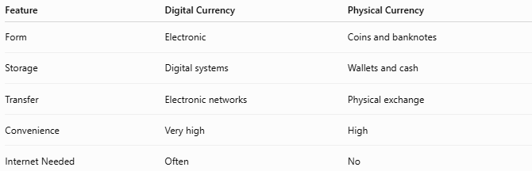
Feature | Digital Currency | Physical Currency
Form | Electronic | Coins and banknotes
Storage | Digital systems | Wallets and cash
Transfer | Electronic networks | Physical exchange
Convenience | Very high | High
Internet Needed | Often | No

Digital Currency vs. Cryptocurrency
# Source: AI Source: Provided by: [Data Path: Persons Table -> ID Column: 1, Name_En Column: Motasem Essam] -> From: [ChatGPT] on [7/17/2026]
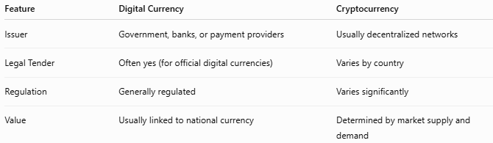
Feature | Digital Currency | Cryptocurrency
Issuer | Government, banks, or payment providers | Usually decentralized networks
Legal Tender | Often yes (for official digital currencies) | Varies by country
Regulation | Generally regulated | Varies significantly
Value | Usually linked to national currency | Determined by market supply and demand

Security Features
# Source: AI Source: Provided by: [Data Path: Persons Table -> ID Column: 1, Name_En Column: Motasem Essam] -> From: [ChatGPT] on [7/17/2026]
Digital currency systems commonly use:
- Encryption
- Passwords
- PINs
- Two-factor authentication (2FA)
- Biometric authentication
- Fraud detection systems

Common Mistakes
# Source: AI Source: Provided by: [Data Path: Persons Table -> ID Column: 1, Name_En Column: Motasem Essam] -> From: [ChatGPT] on [7/17/2026]
- Confusing digital currency with cryptocurrency.
- Assuming all digital currencies are issued by governments.
- Believing digital currency always requires a blockchain (many forms of digital currency use conventional banking infrastructure instead).

Interesting Facts
# Source: AI Source: Provided by: [Data Path: Persons Table -> ID Column: 1, Name_En Column: Motasem Essam] -> From: [ChatGPT] on [7/17/2026]
- Many countries are researching or testing Central Bank Digital Currencies (CBDCs).
- Most money in modern economies already exists as electronic balances rather than physical cash.
- Digital currencies support the growth of cashless societies.

Comparison with Other Types of Currency
# Source: AI Source: Provided by: [Data Path: Persons Table -> ID Column: 1, Name_En Column: Motasem Essam] -> From: [ChatGPT] on [7/17/2026]
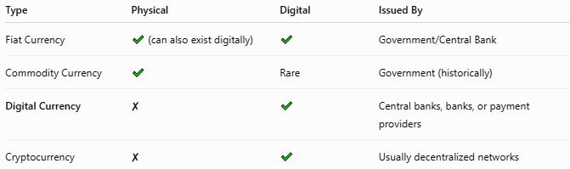
Type | Physical | Digital | Issued By
Fiat Currency | ✔ (can also exist digitally) | ✔ | Government/Central Bank
Commodity Currency | ✔ | Rare | Government (historically)
Digital Currency | ✘ | ✔ | Central banks, banks, or payment providers
Cryptocurrency | ✘ | ✔ | Usually decentralized networks

Key Points
# Source: AI Source: Provided by: [Data Path: Persons Table -> ID Column: 1, Name_En Column: Motasem Essam] -> From: [ChatGPT] on [7/17/2026]
- Digital Currency exists only in electronic form.
- It enables:
  - Online payments
  - Mobile banking
  - Electronic transfers
- Major types include:
  - Central Bank Digital Currency (CBDC)
  - Commercial bank money
  - Electronic money (E-money)
  - Cryptocurrency
- Digital currency is becoming an increasingly important part of modern financial systems.

Conclusion
# Source: AI Source: Provided by: [Data Path: Persons Table -> ID Column: 1, Name_En Column: Motasem Essam] -> From: [ChatGPT] on [7/17/2026]
Digital Currency is an electronic form of currency that enables the storage, transfer, and exchange of monetary value without physical cash. It supports fast, convenient, and secure financial transactions through digital networks and devices. Digital currencies may be issued by central banks, commercial banks, or licensed payment providers, and they form a key component of today's increasingly digital economy. While cryptocurrencies are one type of digital currency, not all digital currencies are cryptocurrencies, making digital currency a broader category within modern monetary systems.

